**Creation of Partner URL and credentials**

1. Partner #1

Name - Urban Company

admin - [minshularora@urbancompany.com](mailto:minshularora@urbancompany.com)

Promo Code - UC0001

Password given : Test@123

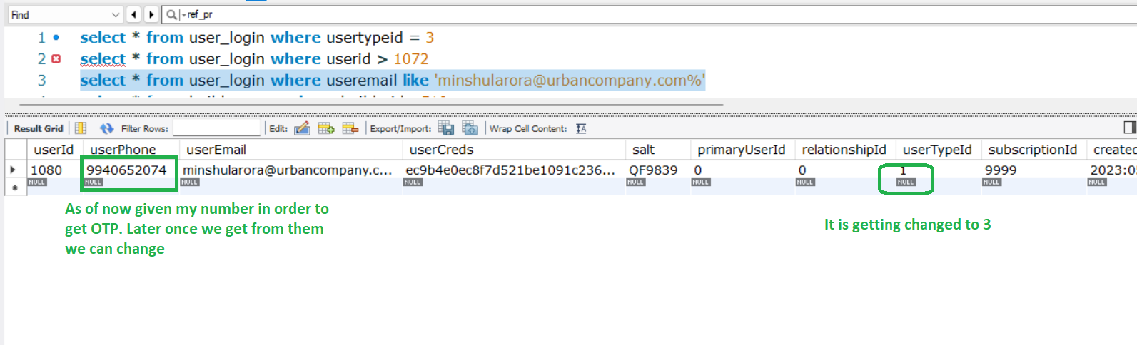

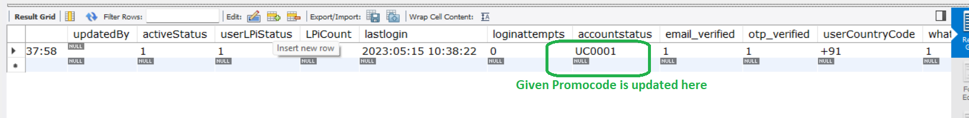

<http://3.109.225.157/urbancompany/#/Register>

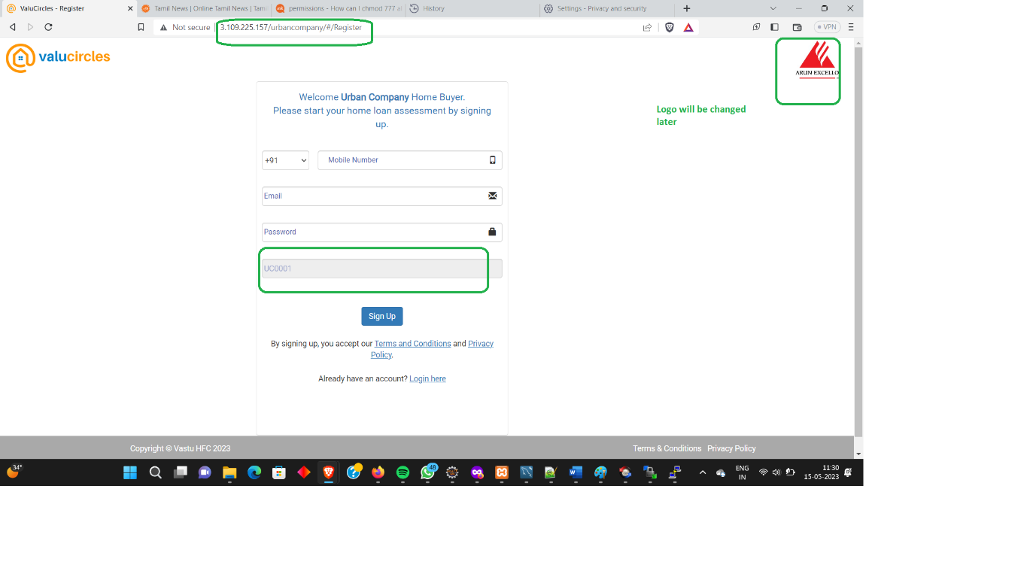

//Checking to see how the page diverts to the requirement page

//Hence using my mobile number to check it.

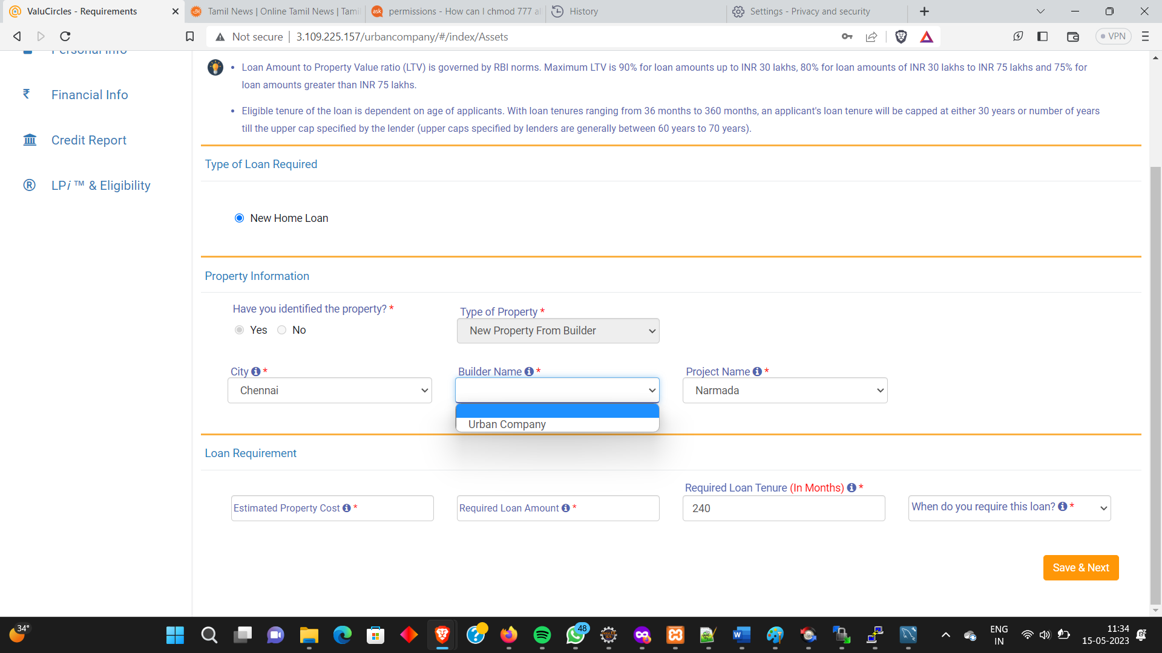

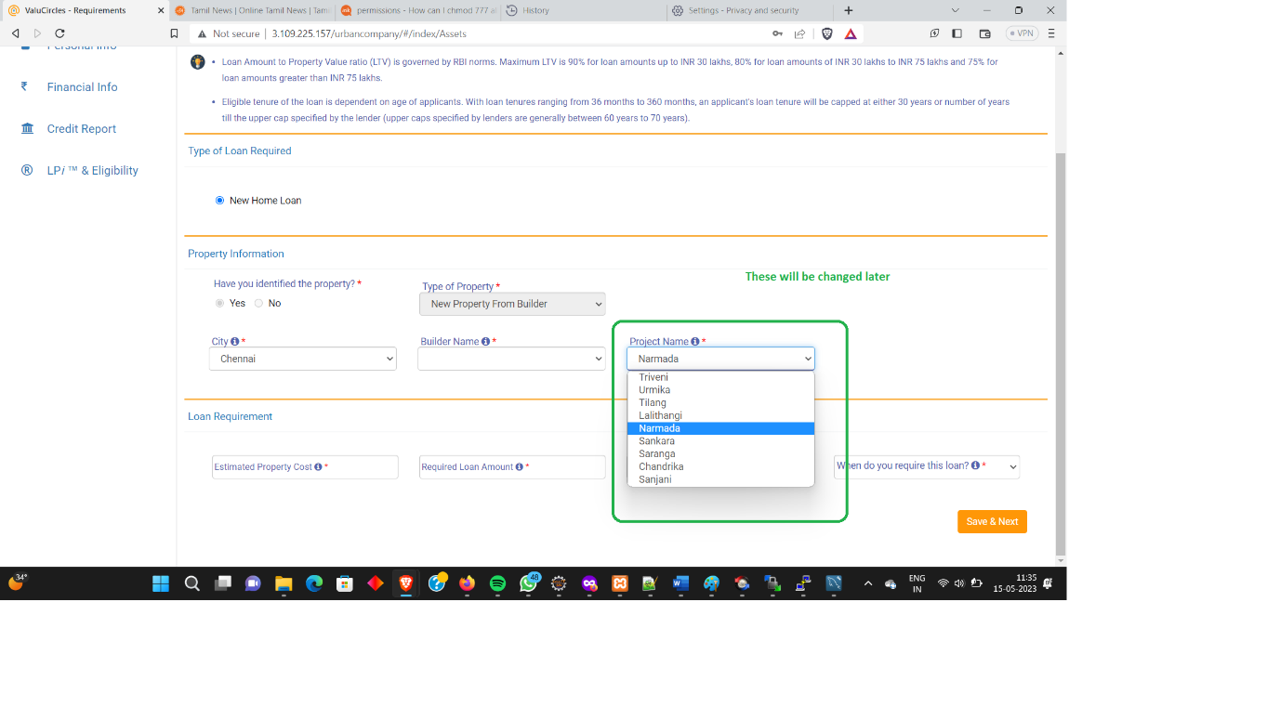

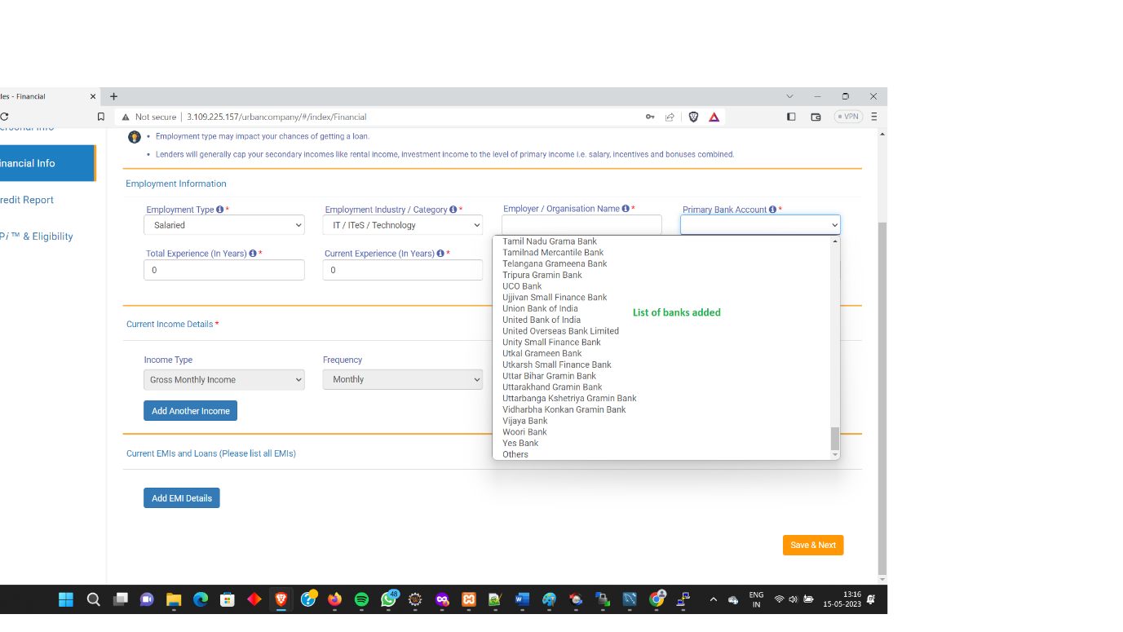

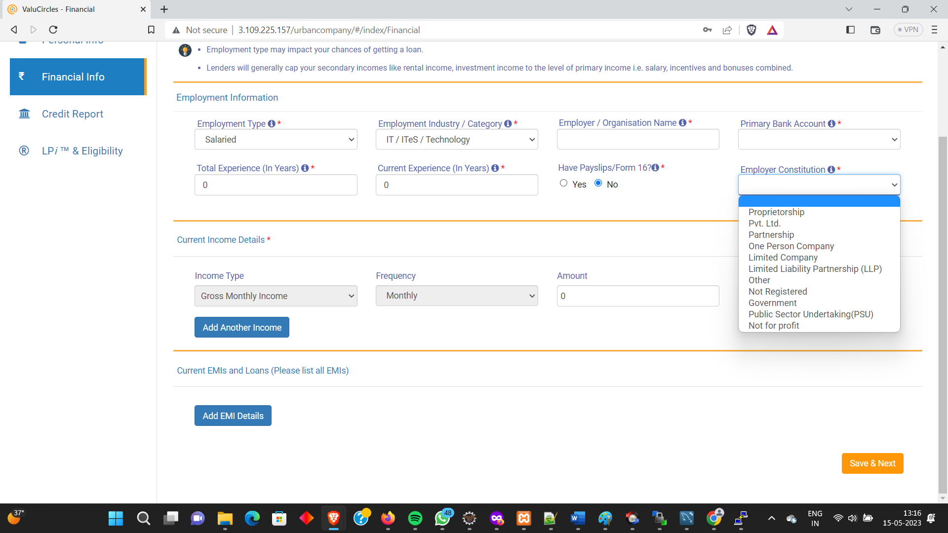

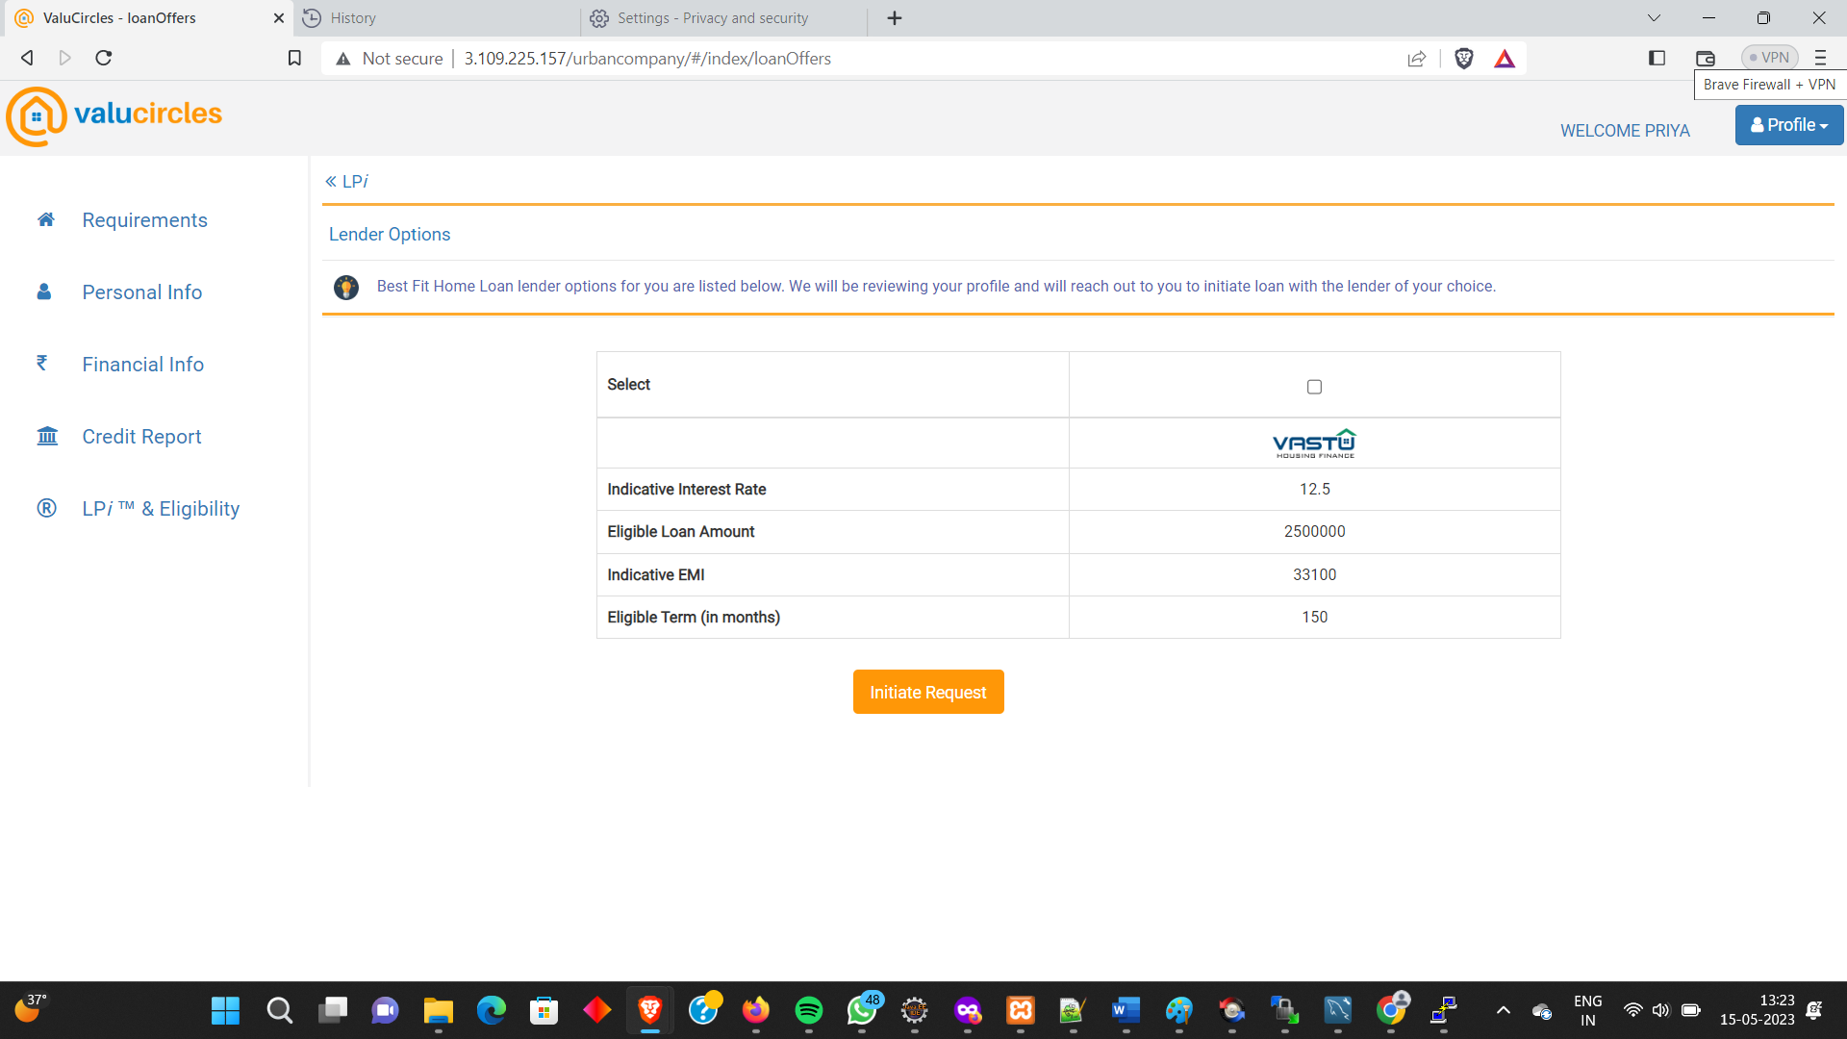

Checking the details via partnerportal using partner admin login

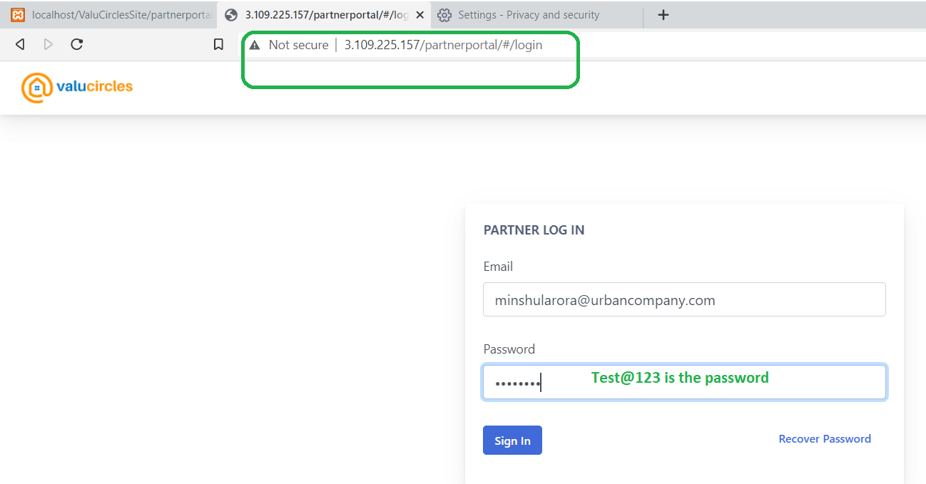

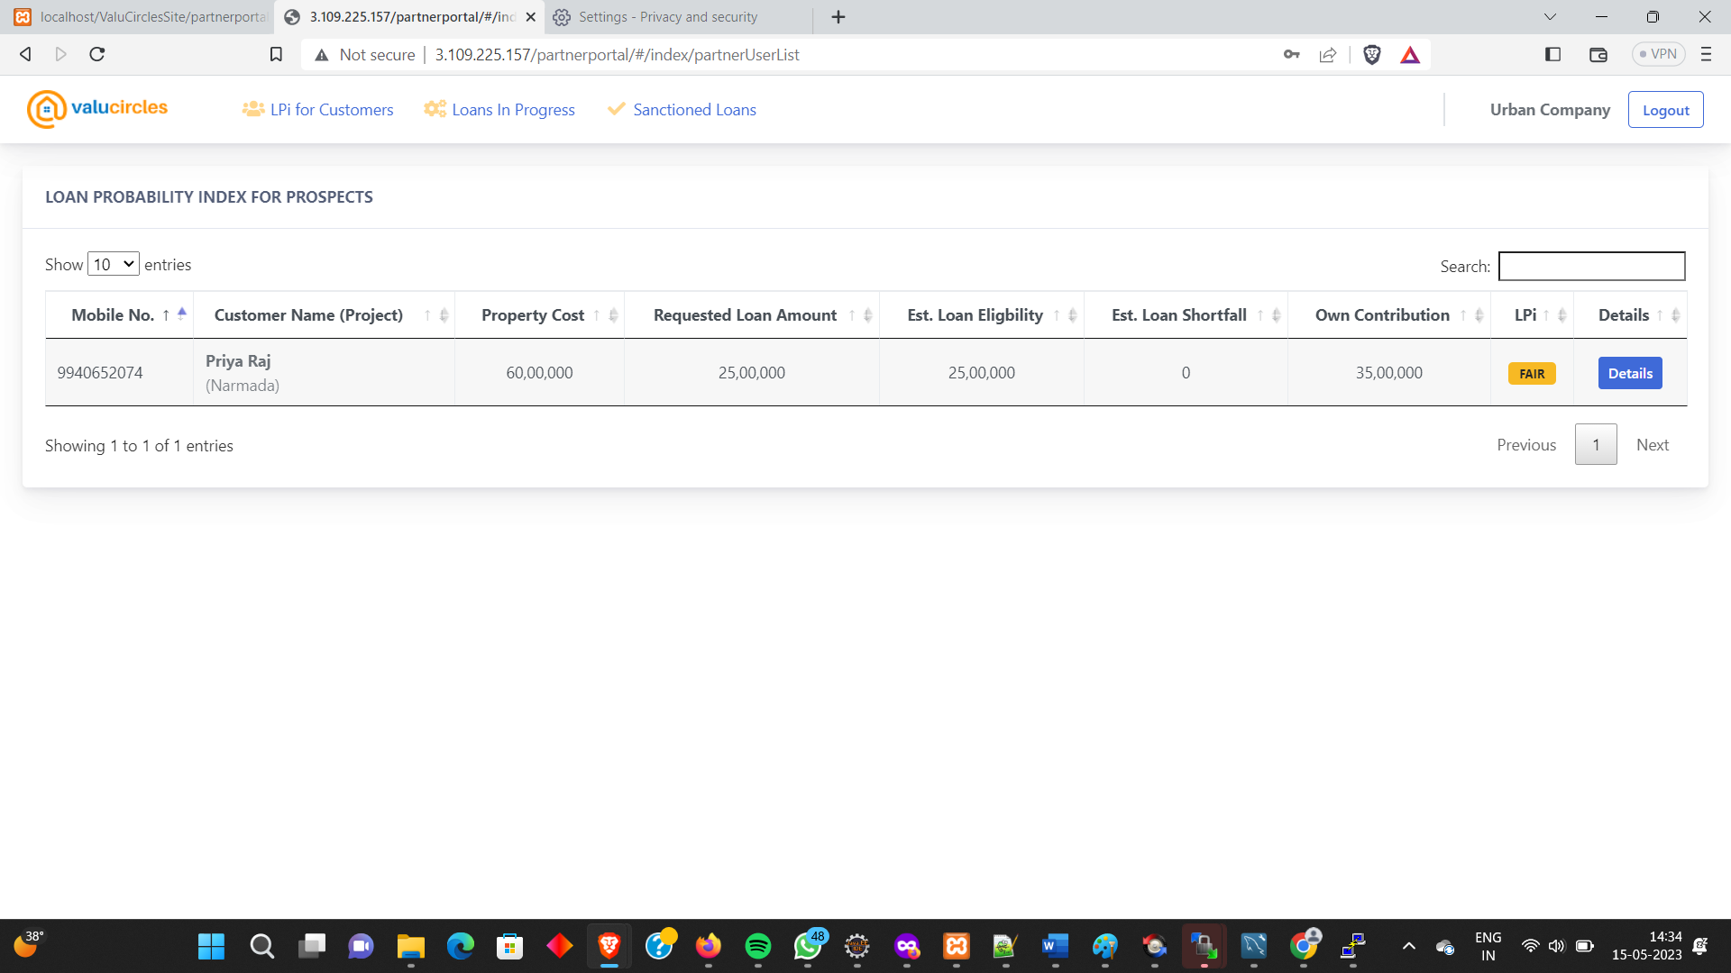

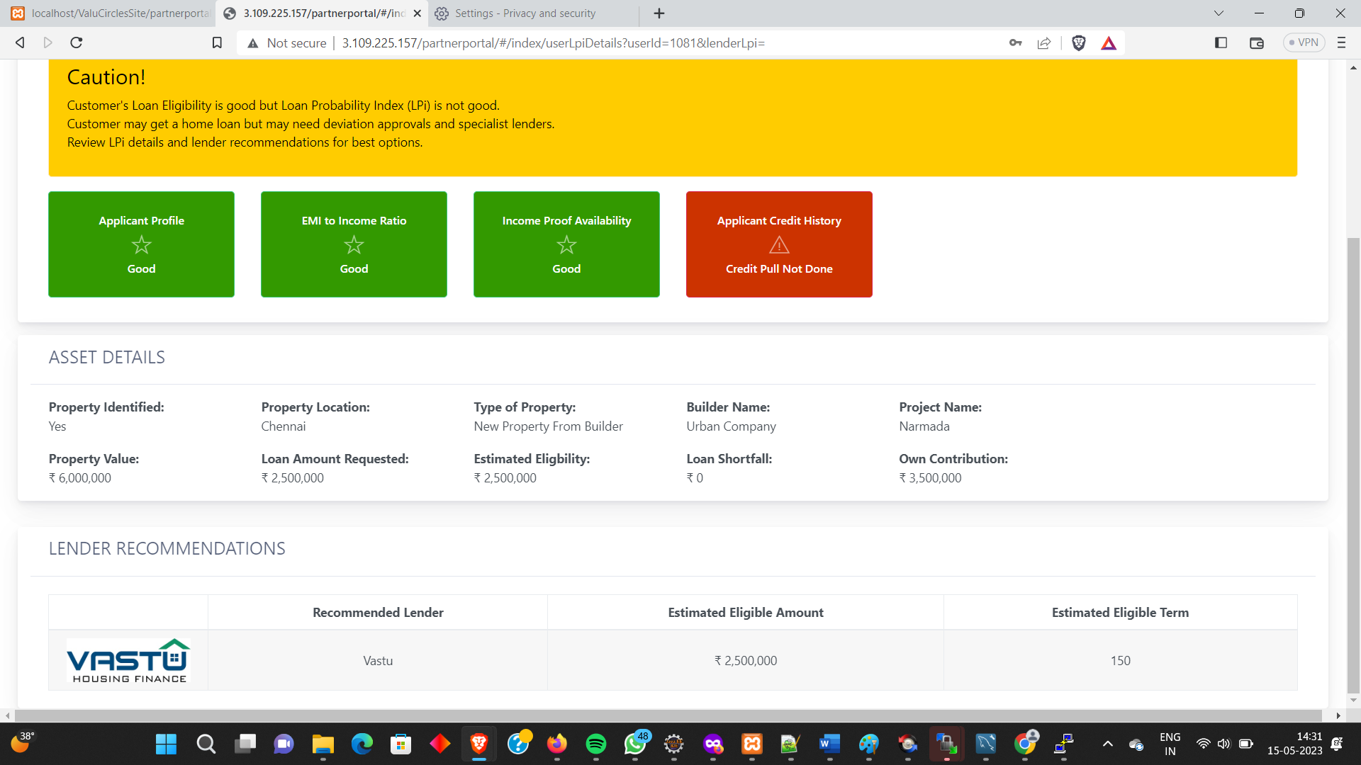

2.Partner #2

Name - WeRize

admin - [mahesh.hegde@werize.com](mailto:mahesh.hegde@werize.com)

Promo Code - WR0001

Password given : Test@123

